SECTION 4

4. (a)

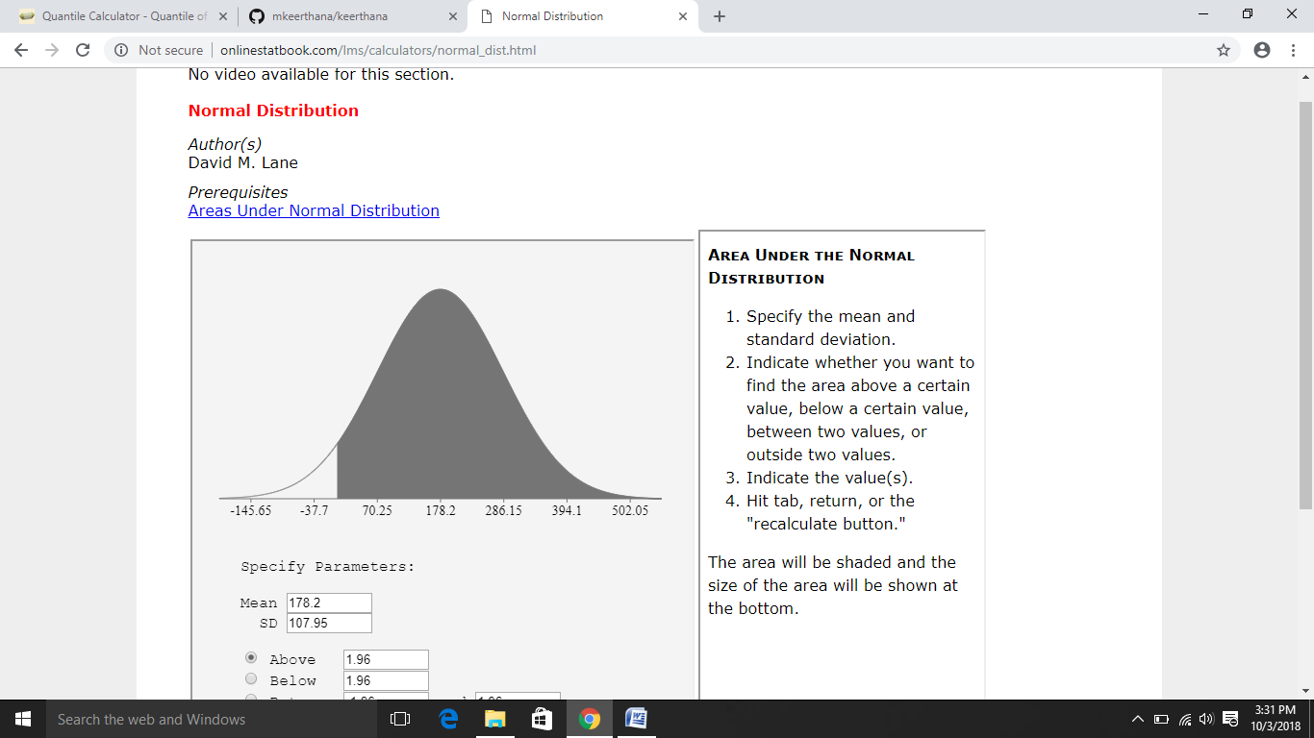

(b) Mean = 178.2

Variance = 97.16

(c) 90% Confidence Interval:

FORMULA:

Upper Limit=Mean+Z0.90(SD/sqrt(n))

Lower Limit=Mean-Z0.90(SD/sqrt(n))

Interval:

UL = 183.327

LL = 173.072